Capstone Proposal
Manav Patel 0301184p
AllerScan
Supervisor: Dr. Lydia Bouzar-Benlabiod

Summary of Your Project Idea in Layperson’s Terms
AllerScan is a mobile app to help people with food allergies check if their food is safe. You take a picture of a food label with your phone, and the app reads the ingredients to spot allergens like peanuts, milk, or wheat. It works offline, so you can use it anywhere without internet, and keeps your data private by processing everything on your device. Designed for Canadians, it supports English and French labels, making it easier to avoid allergic reactions in stores or remote areas

Comparison of 2 Similar Products That Exist (and How Yours Is Different)
- MyFitnessPal: This app tracks nutrition and allows manual ingredient entry to check allergens, but it needs internet and relies on user input, which can be slow. AllerScan improves this with automatic label reading via camera and offline functionality for real-time detection.
- Fooducate: This app scans barcodes for nutritional info and allergen warnings, depending on an online database. AllerScan differs by processing label images on-device, ensuring privacy and accessibility in offline settings, with a focus on Canadian bilingual standards..

Technologies Used
- Frontend Framework: Flutter with Dart for cross-platform mobile development (Android in MVP, iOS in Average Product).
- Text Extraction: Python with Tesseract OCR (integrated via ‘flutter_tesseract_ocr’ plugin, optimized for text extraction) for on-device processing.
- Allergen Detection: Rule-based system with a predefined keyword list, leveraging a synthetic dataset.
- Storage: Temporary image storage via Flutter’s file system and SQLite using the sqflite package for allergen data.
- Styling: Flutter’s built-in widget system for a responsive UI.
- Development Tools: GitHub for version control, VS Code (with Dart plugin) for coding, Android Studio for Android testing, and Xcode for iOS testing (post-MVP).

Timeline
https://app.ganttpro.com/shared/token/c10647f4d5ce56230283363dc8502f0e212179bae83e23db1f74d0e8e2f8f278/1925702

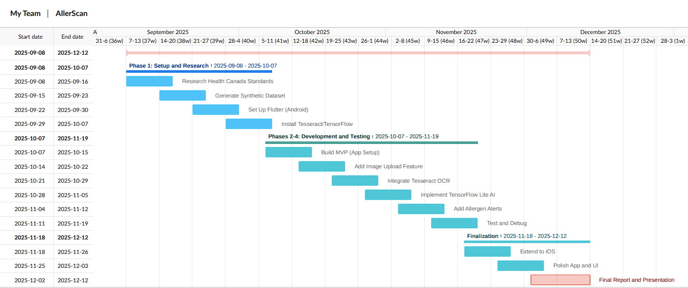

Phase 1
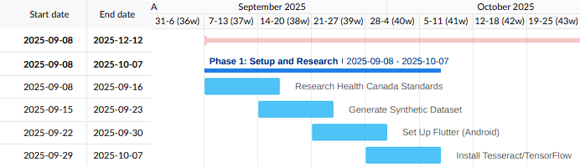

Phase 1-4
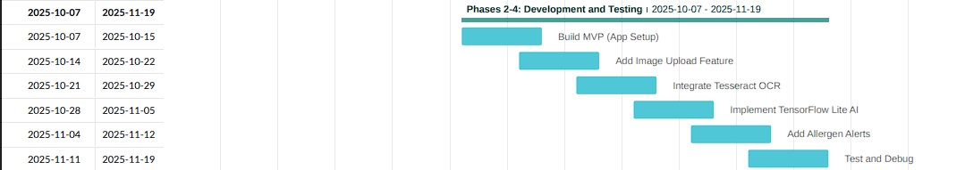

Finalization

Minimum Viable Product (MVP)
- Mobile App Setup: Establish a basic Flutter project configured for Android with a simple navigation structure using Dart.
- Image Upload Feature: Enable users to upload images of food labels via the app’s interface using the ‘image_picker’ Flutter package.
- AI Processing: Use Tesseract OCR, integrated via the ‘flutter_tesseract_ocr’ plugin with optimized settings for text extraction from label images, and a rule-based system to analyze text and detect allergens using a synthetic dataset of Canadian labels.
- Allergen Alerts: Display real-time alerts within the app on the results screen after analysis.

Average Product
- Improved UI: Enhance the upload screen with a preview of the uploaded image and a dedicated results section for allergen alerts, available on both Android and iOS.
- Cross-Platform Support: Extend the Flutter setup to include iOS alongside Android, leveraging Flutter’s native cross-platform capabilities, ensuring compatibility with iOS 14+ and Android 8+.
- Offline Database: Integrate a basic SQLite database using the sqflite package to store allergen terms and synonyms for offline reference on both platforms.
- Performance Tuning: Optimize Tesseract OCR processing to reduce latency on Android and iOS devices, based on initial testing results.

Ideal Product
- Advanced Alerts: Add haptic feedback using the Vibration Flutter package and color-coded alerts (e.g., red for risky, green for safe) with custom widgets to improve user experience on both platforms.
- Bilingual Processing: Fully support English/French label analysis for Canadian compliance.
- User Feedback: Include a simple form using Flutter’s Form widget for users to report inaccurate alerts, aiding future rule refinements.

Goals for the Project
- Empower Users with Accessibility: Provide a practical solution for allergy sufferers to safely navigate food choices, especially in offline settings.
- Develop On-Device Processing: Implement a lightweight system optimized for mobile hardware, using Tesseract OCR with performance-tuned settings and rule-based allergen detection to ensure privacy and efficiency without external servers or heavy AI training.
- Enhance User Experience: Design an intuitive interface with real-time alerts and educational features to support users in understanding allergen risks.
- Tailor to Canadian Context: Focus on Canadian labeling standards, including bilingual (English/French) support and recognition of “may contain” warnings.

Concerns/Risks (in Terms of Completion)
- Weaknesses: My limited experience with Android app development and Tesseract OCR optimization could slow progress. Tesseract OCR may struggle with varied label fonts or low-quality images, affecting accuracy.
- Risks: OCR performance may lag on low-end devices if not optimized, and a small or unrepresentative synthetic dataset could reduce reliability. Delays in debugging or iOS expansion (Average Product) might push the timeline.
- Mitigation: Weekly meetings with Dr. Bouzar-Benlabiod will leverage her ML expertise to optimize Tesseract OCR. I’ll test the current 500-label dataset early, adjusting scope (e.g., delaying iOS) if needed, and focus on rule-based analysis to avoid heavy AI training.

References
- Health Canada. (2023). Food Allergen Labelling Regulations. [https://www.canada.ca/en/health-canada/services/food-nutrition/food-labelling/allergen-labelling.html]
- Open Food Facts. (2025). Canadian Food Product Database. [https://world.openfoodfacts.org/country/canada]
- Flutter Documentation. (2025). Flutter Development Guide. [https://docs.flutter.dev]
- Tesseract OCR. (2025). Tesseract User Manual. [https://tesseract-ocr.github.io]
- MyFitnessPal. (2025). Nutrition Tracking App. [https://www.myfitnesspal.com]
- Fooducate. (2025). Food Scanner App. [https://www.fooducate.com]

